Welcome to the Agency of Agriculture NEW ONLINE LICENSING page. Below is a list of the Frequently Asked Questions (FAQ) and a guide on how to renew online using your VTPlants ID and PIN number.
IMPORTANT: Online renewals open 45 days before your renewal expiration date. We will also mail paper renewals by December 11th for applicators that have not renewed online.
ALL APPLICATORS: Please see specific instructions in red below.
RECIPROCAL Applicators: Online licensing is not available, please call 802-828-2436

- Frequently Asked Questions (FAQ)
- How to renew/register online

Contents
- Why should I register?
- What information do I need to register?
- How will I get a renewal?
- Where do I find my VtPlants ID and PIN?
- I can’t remember if I registered previously or not, what should I do?
- What do I do if I forgot my password?
- HOW TO REGISTER
- How do I renew my license online?
- Why does my shopping cart say, “You have no items that require payments”?
- Will I need to submit a label/SDS when registering a product for the first time?
- Will I need to submit a label/SDS when renewing products?
- When do you charge a late fee?
- Which programs allow online registration?

(Back to Top)

Why should I register?
Once you register you can manage your license(s), renew them online, print your own license(s), review payment history and update contact information. Online licensing is a fast and easy way of renewing licenses as it saves time and money for our customers.
This is the list of programs allowing online registration currently.

Apiary | Commercial Applicator | Dealer Repairman
Feed Products | Fertilizer Products | Ginseng
Government Applicator | Lime Products | Maple Dealer/Processor
Non-Commercial Applicator | Nursery Dealer | Pesticide Company
Pesticide Dealer A | Pesticide Dealer B | Pesticide Products
Private Applicator | Public Weighmaster | Retail
Seed Dealers | Weights & Measures

(Back to Top)

What information do I need to register for online licensing?
In order to register, you will need your VTPlants ID and your PIN. You also need a valid email address.

(Back to Top)
How will I get a renewal?
This will not change. We will mail you a renewal form 45 days before your license or registration expires

(Back to Top)

Where do I find my VtPlants ID and PIN?
Your VtPlants ID and PIN are printed on your renewal form. If you do not have your renewal form, please contact the Agency at 802-828-2436 or via email: agr.licensing@vermont.gov to obtain your VtPlants ID and/or PIN. Please see the example highlighted below:
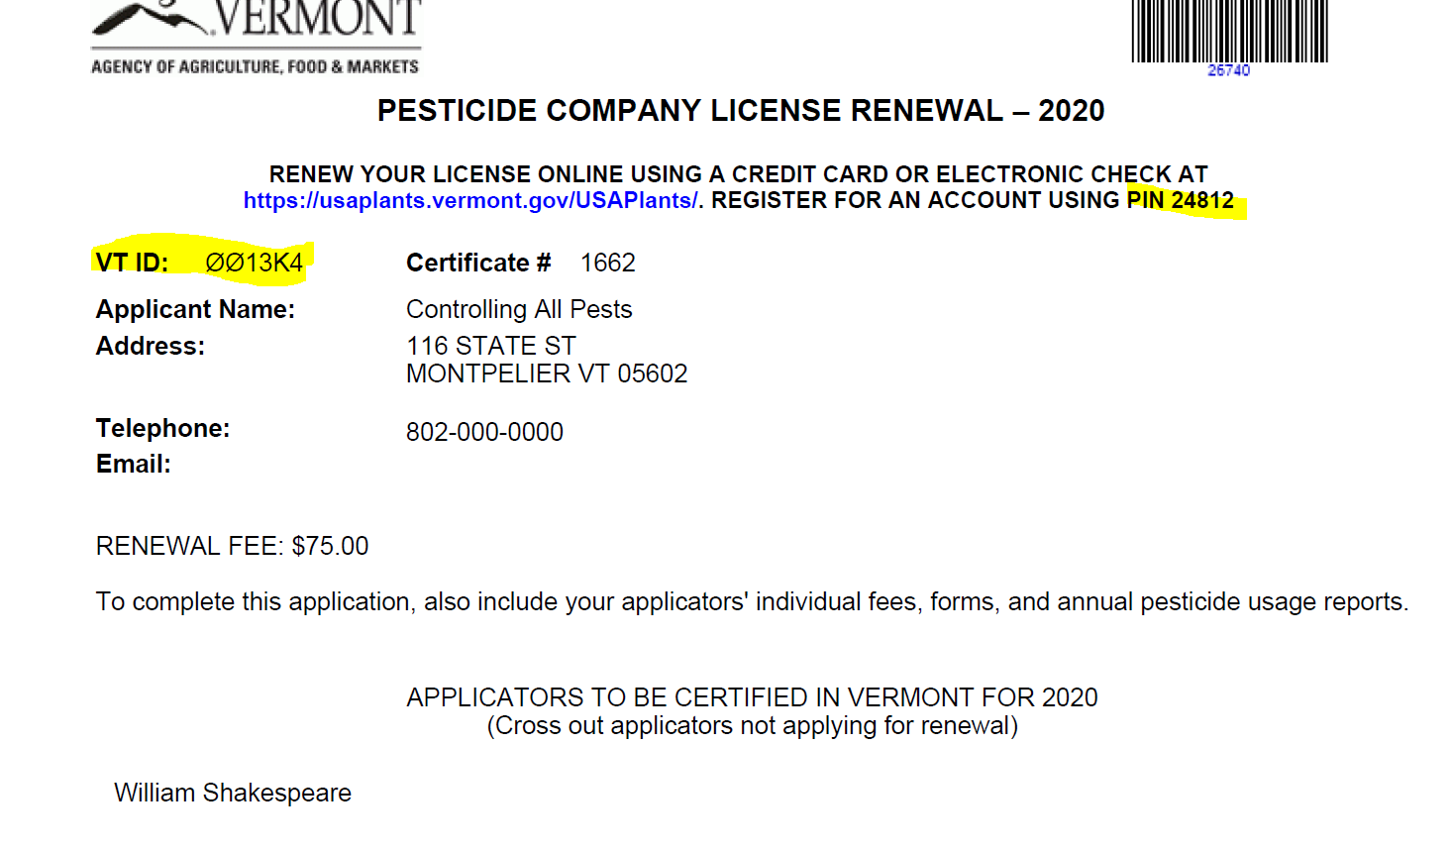

If you do not have a company license, your VTPlants ID and PIN will be on your applicator renewal, please see example below:

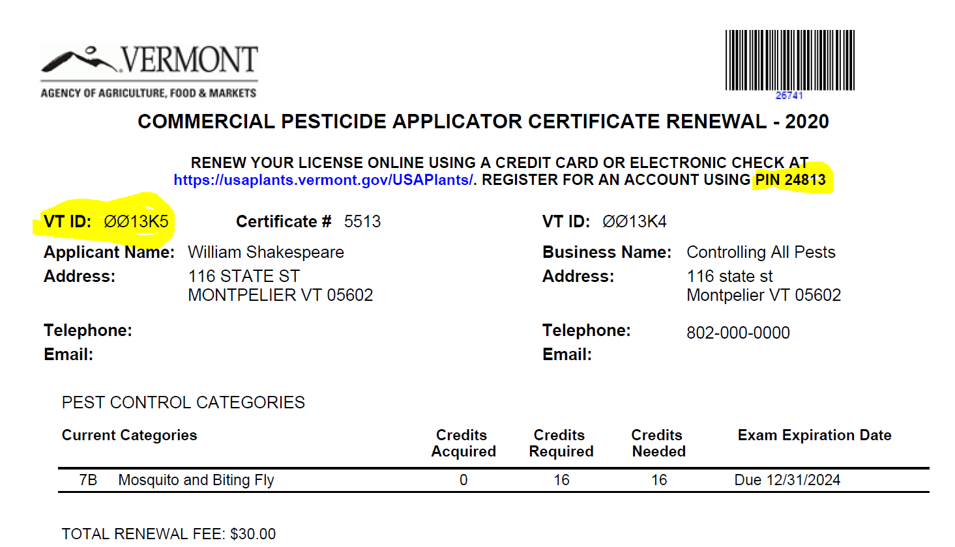

(Back to Top)

I can't remember if I registered previously or not. What should I do?
Try registering again. If you were previously registered, the system will notify you, and send you an email with your username and password.

(Back to Top)

How do I renew my license(s) online?
If you have previously registered with our Agency, please logon to VtPlants using your username and password. If you are registering for the first time please go to Other Options and use the Register button, please follow the instructions on How To Register.

(Back to Top)

What do I do if I forgot my password?
Click on the "Forgot Password" link, and supply either your VtPlants ID or username. The system will email you your password. If your email address has changed, please contact the Agency at 802-828-2436 or via agr.licensing@vermont.gov
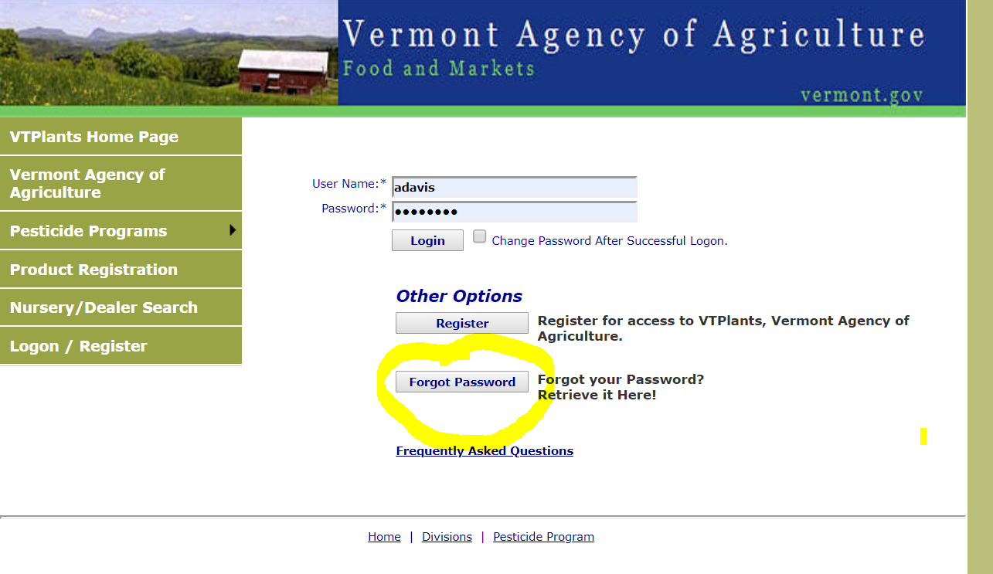

(Back to Top)
HOW TO REGISTER:
- Go to the Login Page.
- Click on the Register button in the middle of the screen.
- Begin by entering your USAPlants ID #.
- Enter the PIN # you were provided.
- Create a username, something unique and easy for you to remember, there are no requirements for special characters such as an asterisk.
- Enter a valid email address. You will need access to this email address for notifications about your license and in case you need to reset your password in the future.
- Enter your first name.
- Enter your last name.
- Enter your phone number.
- Create a password. There are no requirements for special characters so make it something that you can remember. At this point you want to take note of the username and password you created; you will need them to login.
- If by chance you forget to fill something in, a red error message will tell you exactly what needs to be corrected before you can save the form.
- Next, save the form by clicking the SAVE button. An email will be sent to the email address provided.

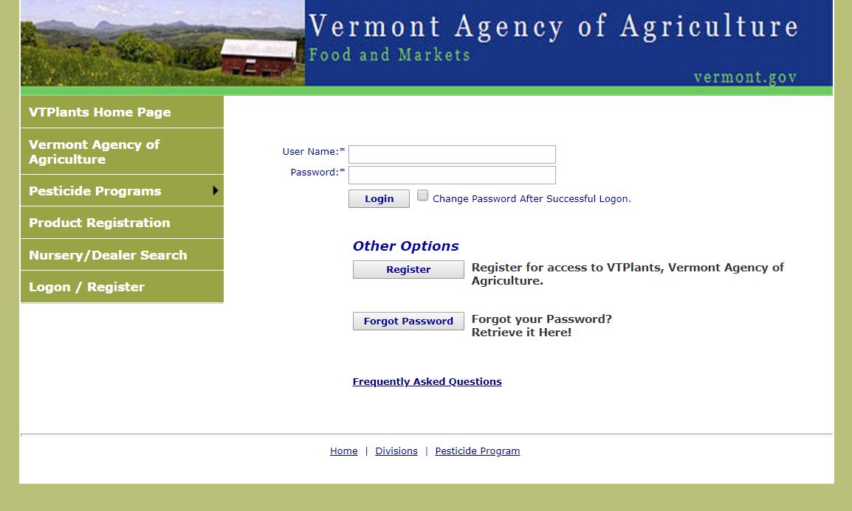

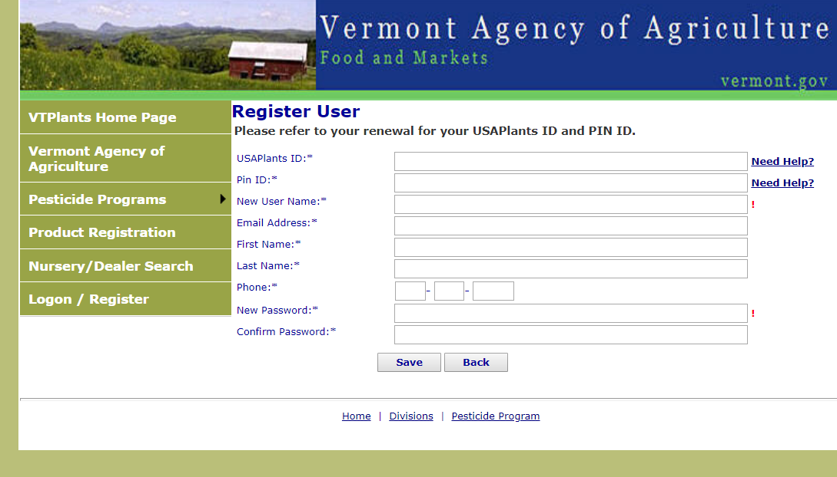

Once you have registered, please click on the "Shopping Cart" menu. All your licenses that are available for renewal will be shown.

Business Licenses and Commercial Applicators: please register your Business License and follow the instructions to renew.

All Commercial Applicators: please enter your Usage Data before you renew your license, otherwise you will get a message in red instructing you to do so. Please click on Enter Missing Usage Data, see example below. Please upload your Usage Report.

Non-Commercial and Government Applicators, please note you will have to upload a usage report even if you have no usage to report. Please make sure your name is included on the report.

Please click on Enter Missing Usage Data (see example below). Below is the link to the Usage Report form:..\..\Forms and documents\Annual Pesticide Usage Report.pdf

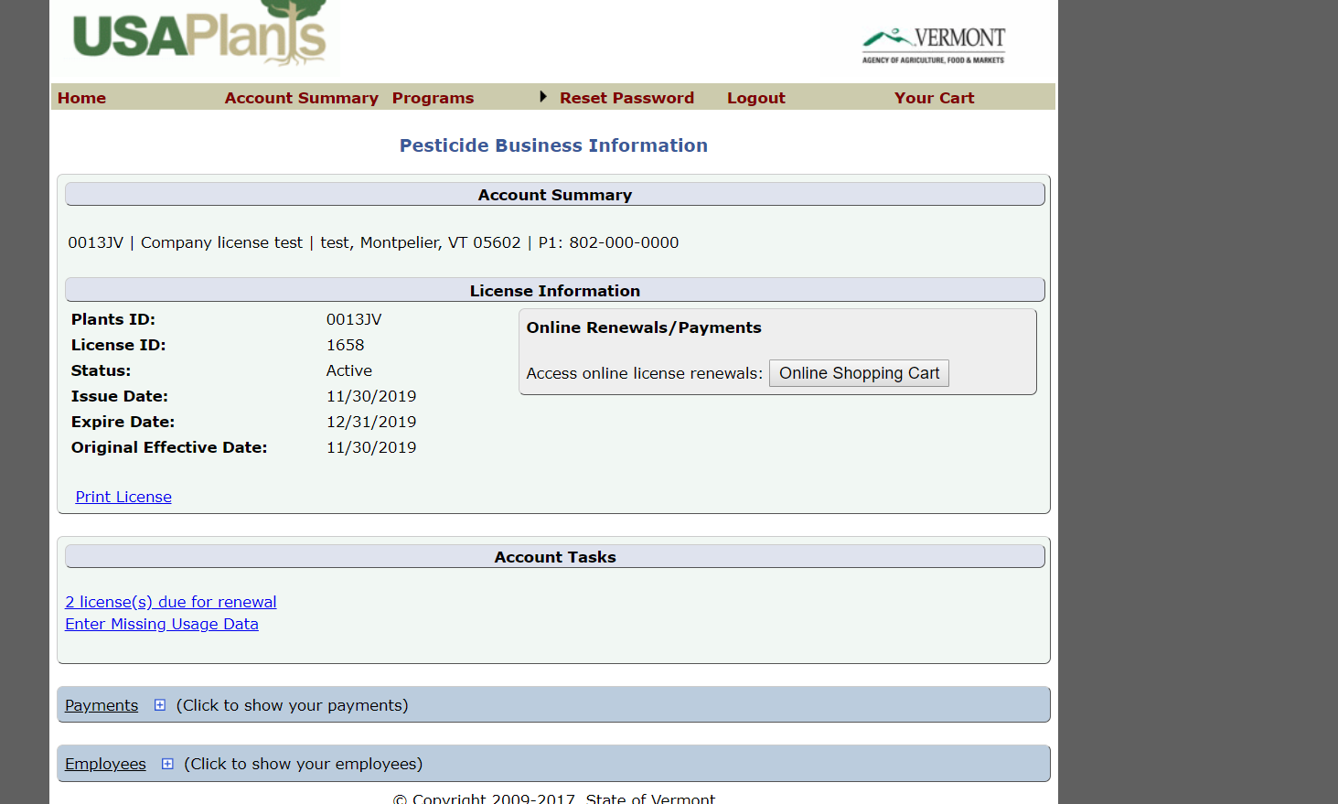

Commercial Applicators: Once on the Brand Usage Entry place a checkmark on each of the applicators you wish to renew.

Scroll down the page to ‘Search Brands for EPA Number’ and fill in the information, you will have to click the SAVE button each time you do an entry of a pesticide usage.

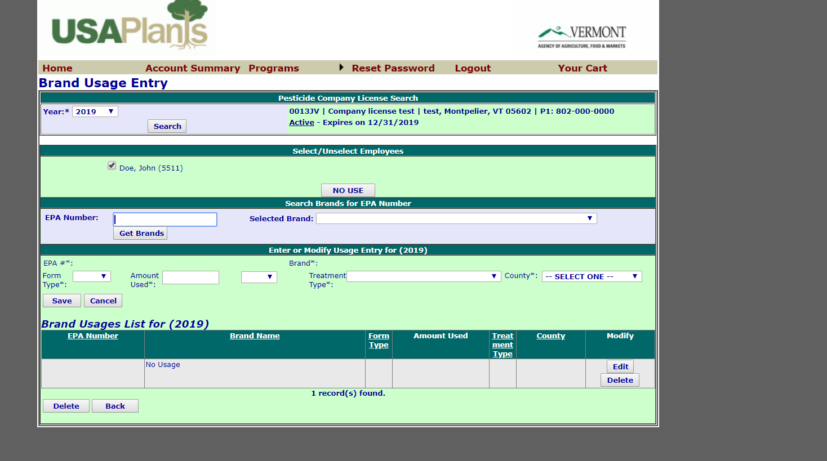

Once you are finished entering your usage data, please click on the BACK button, this will bring you to the Online Shopping Cart where you should be able to select your licenses to renew.

Non-Commercial and Government Applicators: Once you get to the License Verification Information page, a message will appear informing you to upload a Usage Report form (even if you have no usage to report, in this case write “NO USE” on the report form) and this will bring you to the Online Shopping Cart. Please make sure to include your name in the usage form.
Private Applicators: please follow the How to Register instructions as you do not have usage reporting.

You will now be in the Pesticide Business Information and should be able to go to the Online Shopping Cart.

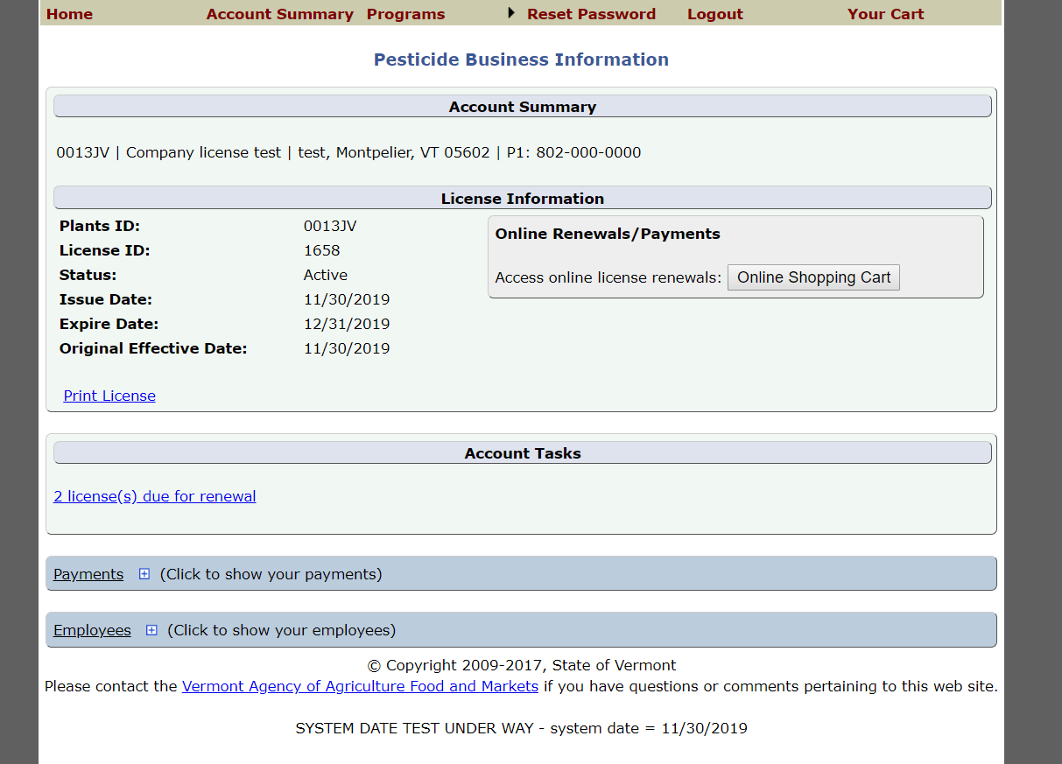

Please select the licenses you wish to renew and click on Add Selected Items to Cart.

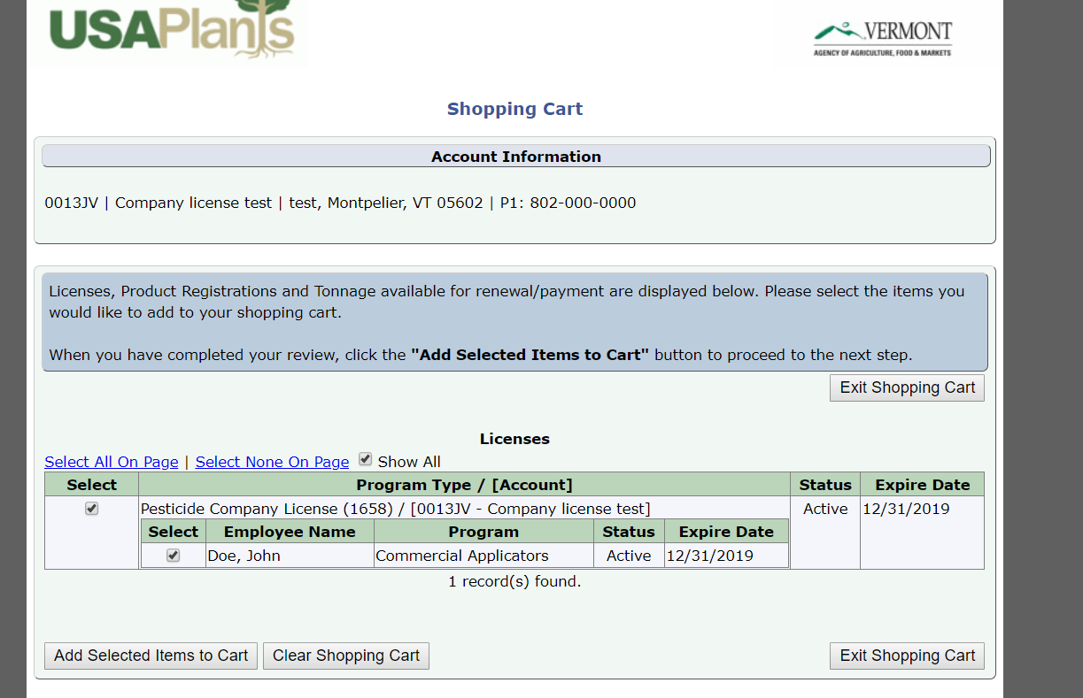

Verify the license information by clicking on the "Verification Needed" link.

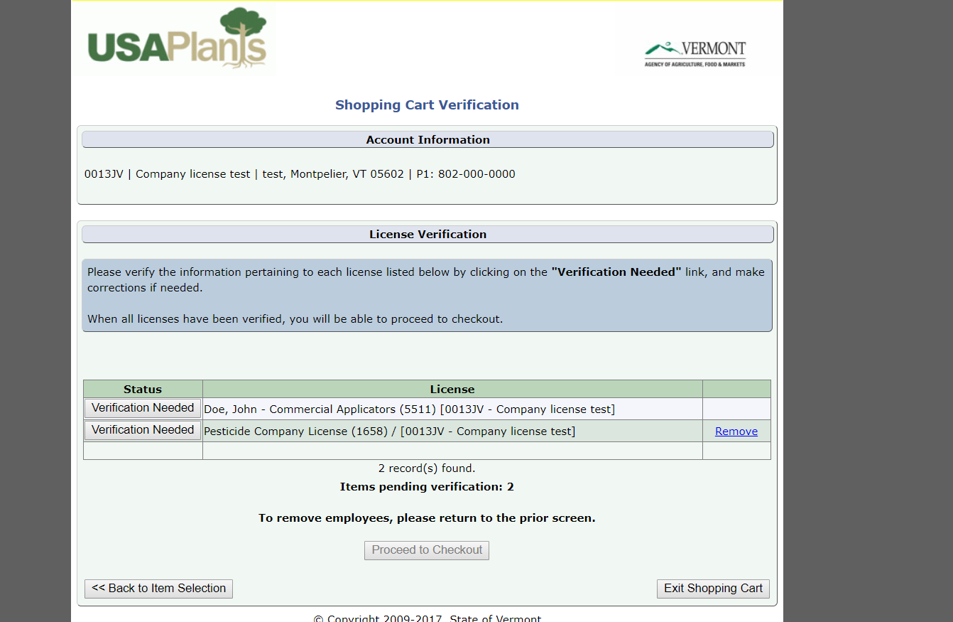

Below is an example of what the page will look like while you are in the process of verifying.

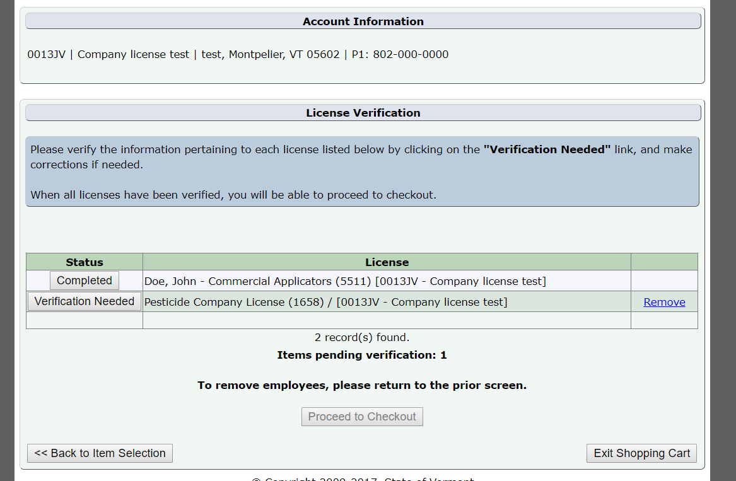

If any changes need to be made to the mailing address, phone number or email, you may do so here. If everything is correct, click on “Accept and Continue” to supply your payment information.

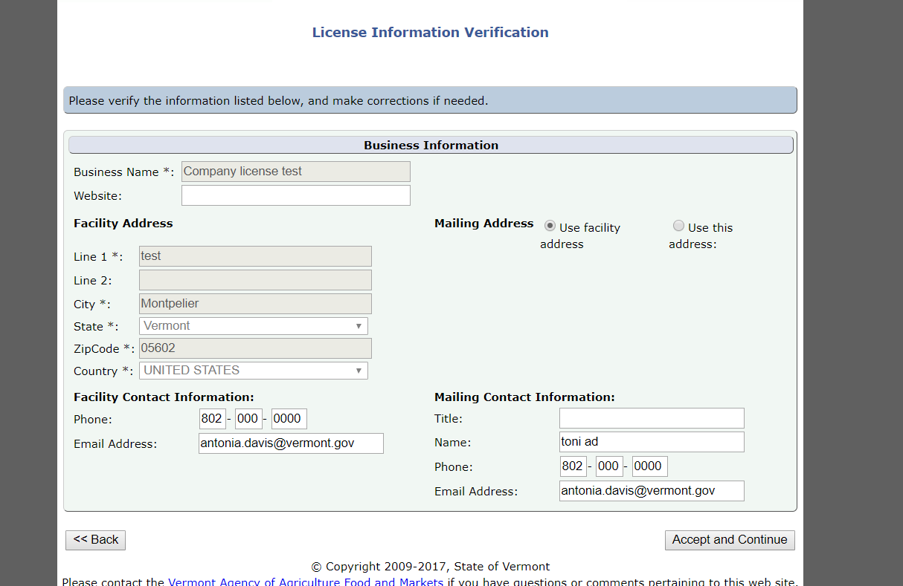

You will now be taken to the “Proceed to Checkout” payment information:

Please read all statements under Certifications carefully. If in agreement, click on all checkboxes in order to complete your registration (scroll down to each of them, depending on your license they may be different). All boxes must be checked before proceeding to the payment page.

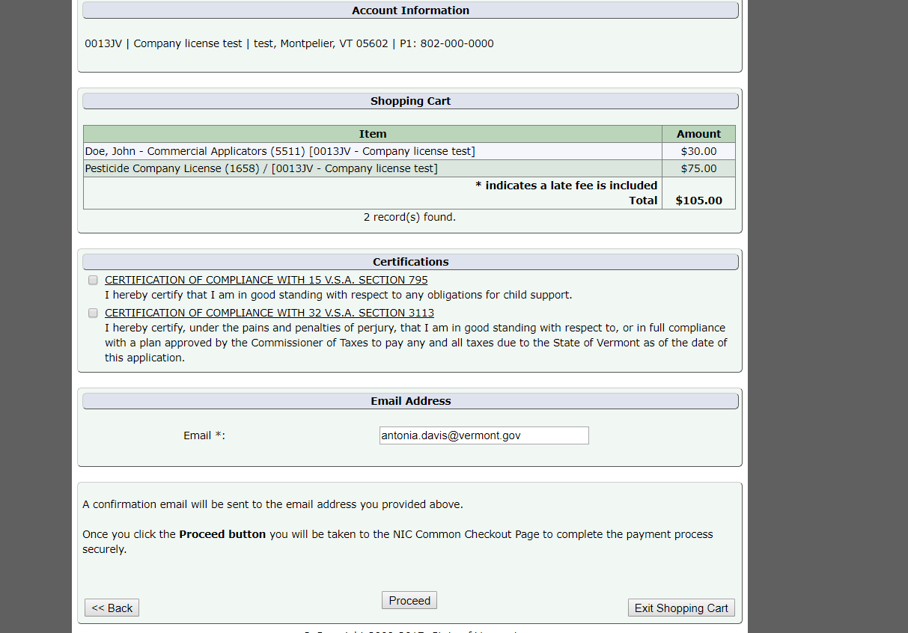

You can now click on Proceed and you will be directed to the supply payment page, which will give you the option to make a payment with either a credit card or e-check.

Please follow the instructions on the supply payment page. You will receive an email with your payment confirmation and a notification if a late fee was included as well. You will see the transaction summary on the right of the page, as in the example below:

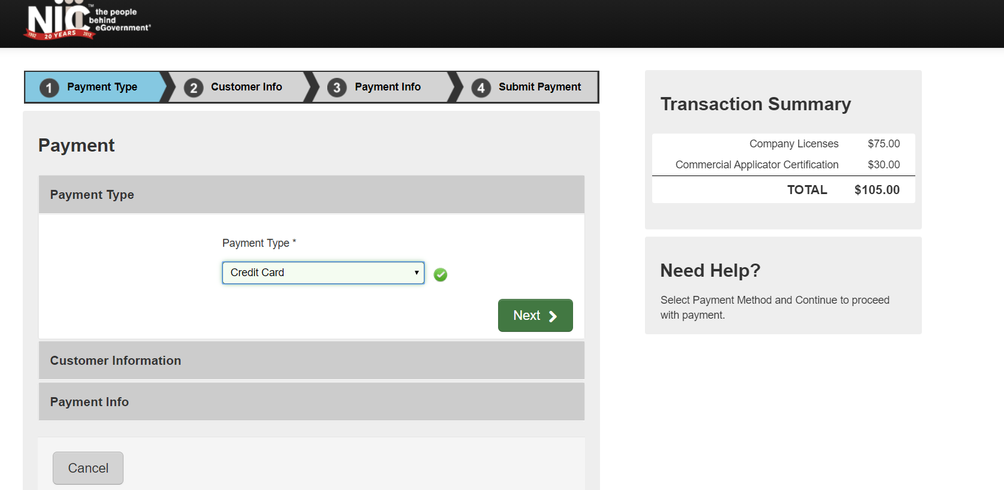

IMPORTANT! See the Shopping Cart field below for explanation on how to obtain your licenses.
Shopping Cart

Please click on the "Print" links below to view and print your licenses.
If there is no "Print" link next to your license, a copy of your license will be sent to you in the mail.
If you have trouble printing, view the Frequently Asked Questions (FAQ).

The transaction confirmation should appear as in the example below.

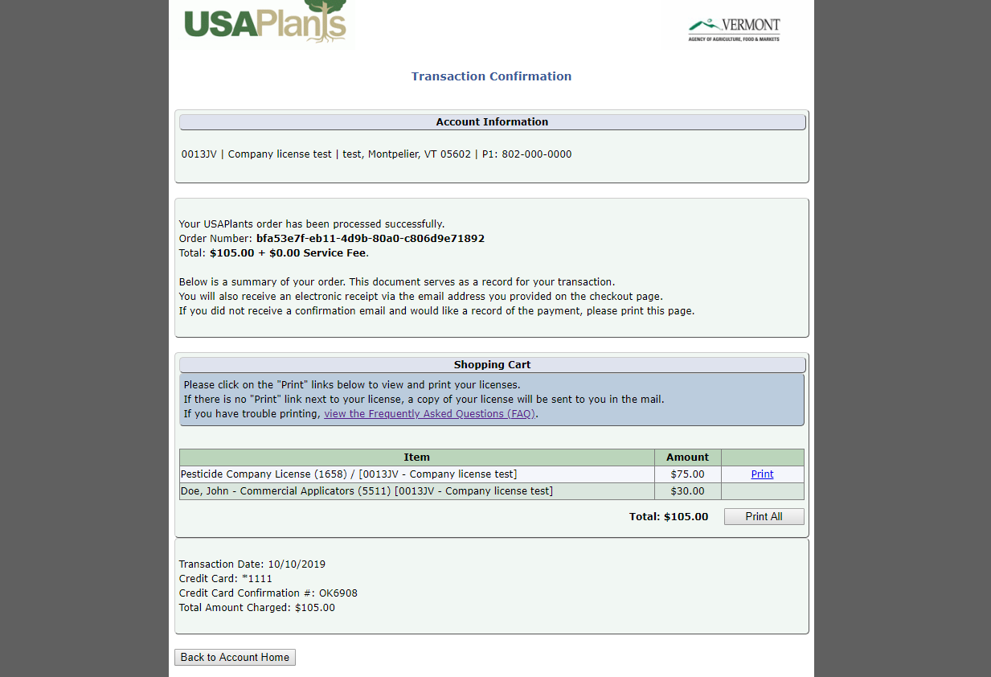

(Back to Top)

Why does my shopping cart say, "You have no items that require payments"?
This could be caused by several reasons:
- You have already renewed your license(s)
- Your account is setup as a "secondary" account to a "primary" account. The "primary" account (usually corporate or headquarters) is the only one that can renew licenses for secondary accounts. If you see a "Business Relationships" grid on your program page, then your account could be a secondary account, i.e. see below:
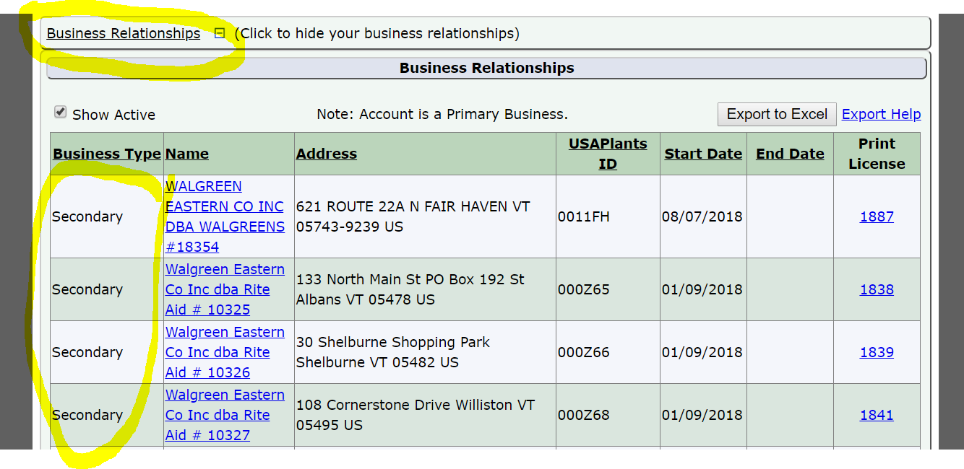
- If your license requires continuing education credits, you may not have enough credits.
If you believe you should be able to renew a license, but do not see it listed, you can contact the department at 802-828-2436 or email agr.licensing@vermont.gov

(Back to Top)
Will I need to submit a product label and/or SDS when registering a product for the first time?
Yes, new Pesticide products will need a label and an SDS to be uploaded into VtPlants in order to be reviewed for approval when registering online, the system will indicate when/where you need to upload your paperwork. Labels can be uploaded to ALSTAR
Feed, Fertilizer and Lime products will need a label uploaded to the system as well.

(Back to Top)
Will I need to submit a label/SDS when renewing products?
Yes, if your product label is not in the system already or you have made changes to your label, you will have to upload it. Labels can be uploaded to ALSTAR

(Back to Top)

When do you charge a late fee?
Renewal licenses not received by the Agency 30 days past their expiration date are required to pay a late fee of $27.00. You can include the late fee with your renewal payment.

Products registration will pay $27.00 per renewal package, not per product.

Retail, Weights & Measures and apiary will pay $27 or 100% of the renewal fee, whichever is less; for instance, if you are license only for Prepackaged Meats which is $15, your late fee will be $15.00 not $27.00.

(Back to Top)

